 | NEURAL NETWORK | Mini Project by group (30%)
BITI 3133 | SEMESTER 2 | SESI 2022 / 2023

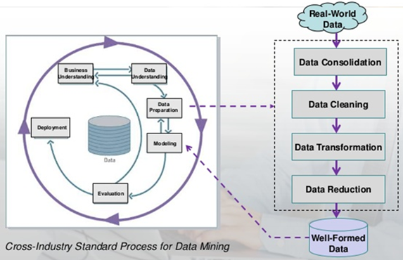
Given Cross-Industry Standard Process for Data Mining as follows:

Take a case study focusing on machine maintenance area using advanced analytical models. Explain every process and describe about their theories by examples.

Group and topic | Question on Tools & Participation | Report Submission | Presentation
S1G1  S1G2 | Cross Question among Group | 21.6.23 | 22.6.23

FORMAT OF THE REPORT (Standard Report complete with the sub topics):
1. Title and members
2. Table of Contents
3. Introduction - manufacturing case study
4. Detail description about samplel data – must understand
5. Flow chart and learning process
6. Step by step learning and analysis
7. How analysis can be conducted
8. Decision/business intelligence model
9. Conclusion
10. References
11. Provide other materials i.e. journal articles in Appendix to justify your idea

